CSS & JS DOM Methods
Working with your Trio/Buddy:
- Discuss: What's one skill from your previous career that you think will be your secret weapon as a developer?
- Reflection: What's still fuzzy? What technical concept are you still wrestling with?
- Explore: What's your LinkedIn strategy? Are you sharing your learning journey publicly?

Stuff is going to start getting complicated — Breadth vs Depth
“It is impossible to know it all! My goal is to have some understanding of many topics, and kind of understand how things work together. I will not stress out about not knowing it all!!”

Please please try to avoid going down rabbit holes!

Note about optional curriculum items:
These are not mandatory, they are resources that we have found helpful for people. If you would like to go a bit deeper into topics please check them out ONLY if you have time and the mental capacity to focus on them. Quickly skim and if you come across information you do not already know then spend some time making sure you understand that topic.

Welcome to the wonderful world of CSS
CSS (Cascading Style Sheets) is how we make the internet beautiful!
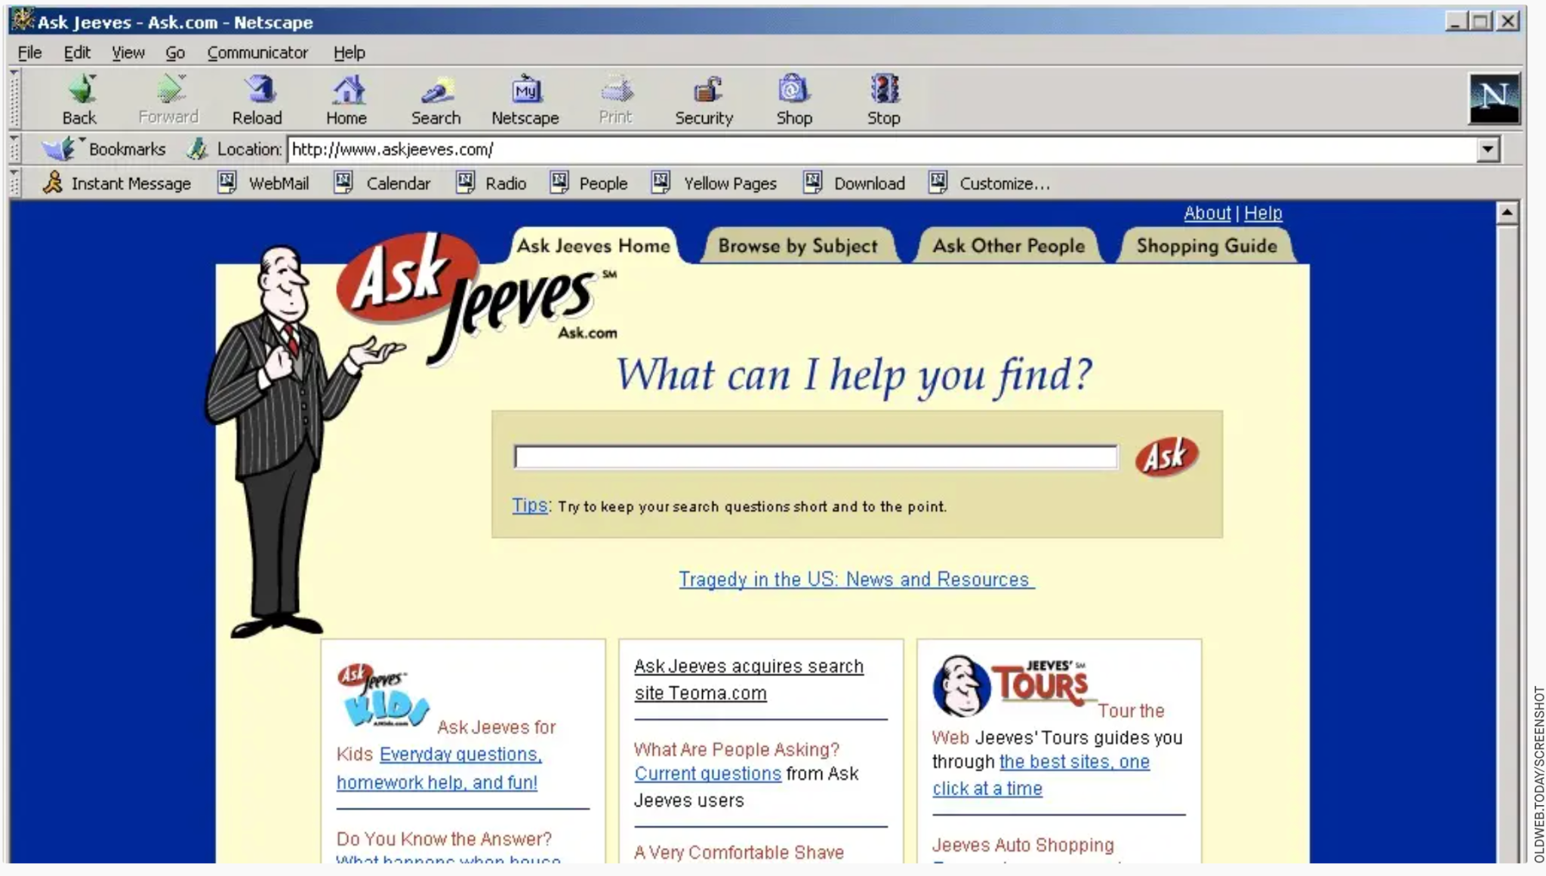
Nextscape 1999.

CSS works by connecting part of your HTML with a style: inline styling or stylesheet.

DO NOT stress out about memorizing everything you will be learning today. In the real world you will use a few things all the time like: color, background, height, width, display, and those you will memorize as you use them.

The DOM
A list of all the elements on the page and how they relate to each other.

- The DOM: The Document Object Model
- Rendering: Basically what the computer is building to display on the screen

Start with What’s the Document Object Model, and why you should know how to use it. It will start to get the vocabulary in your head

JS HTML DOM Methods
You can use JS to alter the DOM. Maybe I have an array of items and for each item I want to make a new <li> tag, maybe I want to make a counter turn red if the value goes above 10. Basically these methods are how websites became interactive.

DOM Manipulation And Events from The Odin Project

⚠️IMPORTANT: I do not expect you to have all of these memorized. I do expect you to be able to have a conversation with me about them. Given examples explain what is going on, and modify what the current code is doing.

Weekly Project & Expectations - Recipe Page
Try to find some time for your recipe page project, but make sure you give yourself time to learn the new stuff too!
- You should be done adding your HTML scaffolding.
- Begin working on incorporating CSS by the end of today.
- Remember to save early and often!
- It is OK if you do not finish the entire project, choose the things you need the most work on and strive for understanding, learning, and getting better instead of a final product. We would much rather you have an “ugly” page to show but really understand everything you

Be Sure to Review these Additional Resources
⚙️Intro to CSS
⚙️CSS Challenge
📄Stuck?
⚙️How to ask good questions

End of day questions:
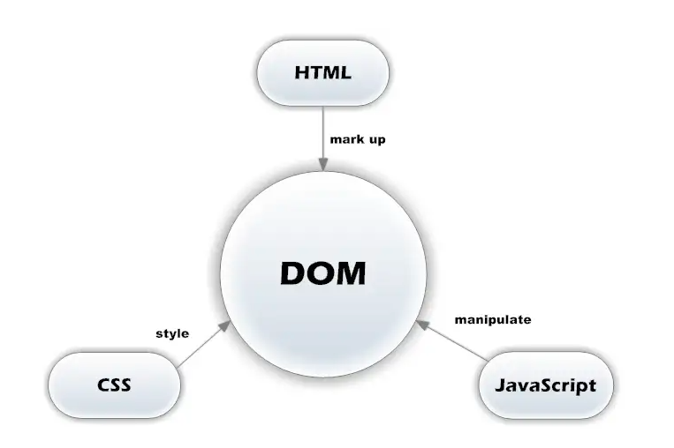
- The DOM
- What is the DOM?
- What kind of events are there? (see a list of event types here)
- What is an event listener?
  - Why might I use one?
- How do I select something in the DOM?
  - Get something by class name
  - Get something by ID
- CSS
- What is CSS?
- Why Cascading
- Does order matter?
- What is the difference between a Class and an ID?
- Do you know what a parent, child, sibling component is?
- What does inline, block, inline-block mean?
  - Can you name one element that natively has each of those display properties?
- General Questions
  - What is something you need to keep in mind when pair programming?
  - Be able to open and navigate around Chrome Dev Tools
  - What is an aspect of “professionalism” you need to work on?
- HTML
- How is an HTML document structured?
- What is the key difference between HTML Elements and Tags?
- JS
- What JS array methods can you name?

Quiz: DOM & CSS

